Name: B.Preethi

Trainer Name: Harshee Pitroda

Course Name: Python and Machine Learning-Basic course

Date:31/05/2022

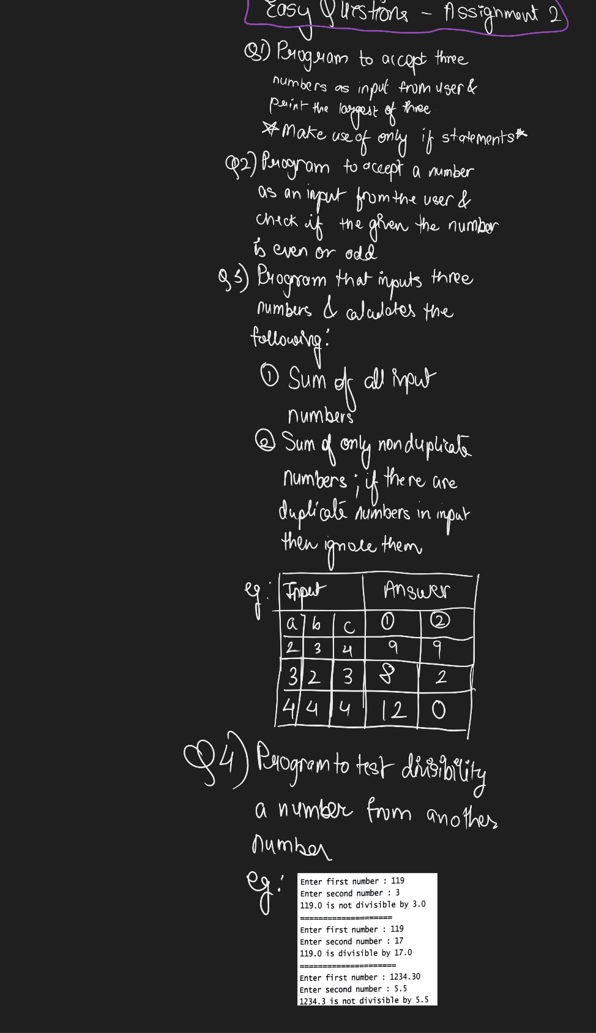

Q1)

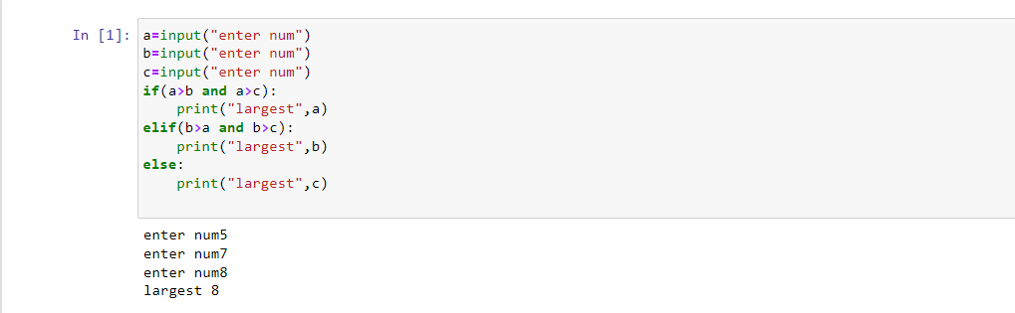

Q2)

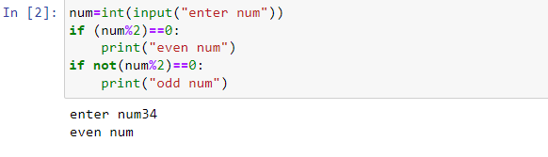

Q3) **SUM of all input numbers:**

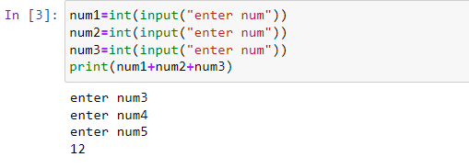

Q3) **SUM of non- duplicate numbers**

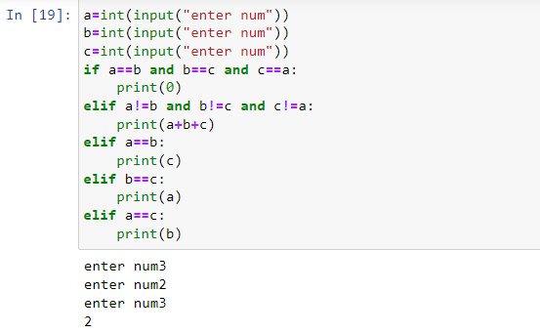

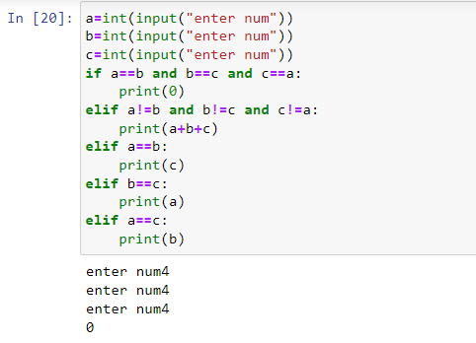

Q4)

